Coding challenge-3: - Hospital management system

Name: Dheeraj Vemula

1.Create SQL Schema from the following classes class, use the class attributes for table column names.

Creating patient table in SQL.

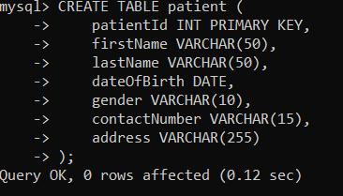

Creating doctor table in SQL.

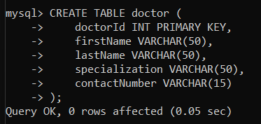

Creating appointment table in SQL.

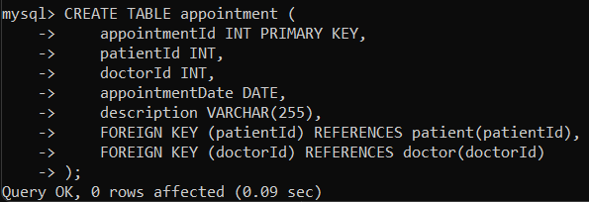

2.Create the following model/entity classes within package entity with variables declared private, constructors (default and parametrized,getters,setters and toString()).Creating `Patient` class with the following confidential attributes:patient_Id, firstName, lastName, dateOfBirth, gender, contactNumber and address;

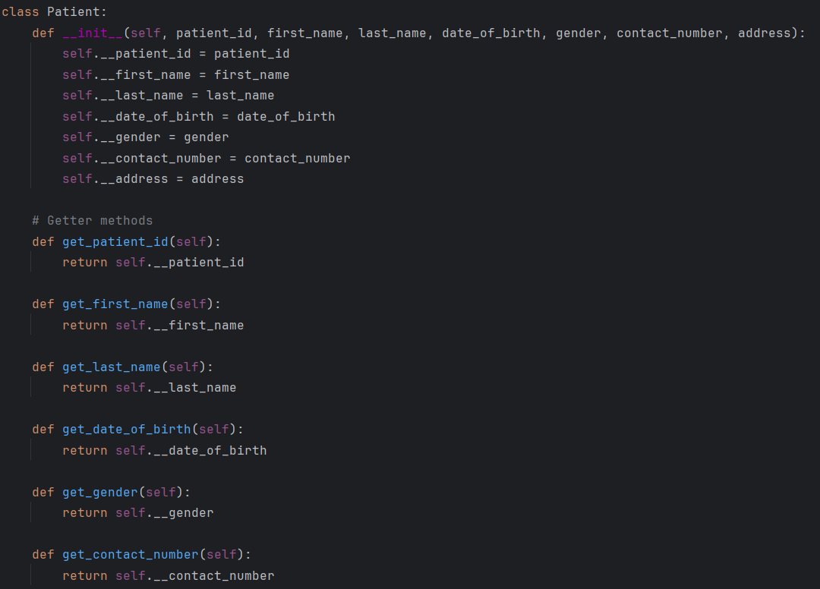

Creating `Doctor` class with the following confidential attributes:

DoctorId, firstName, lastName, specialization, contactNumber;

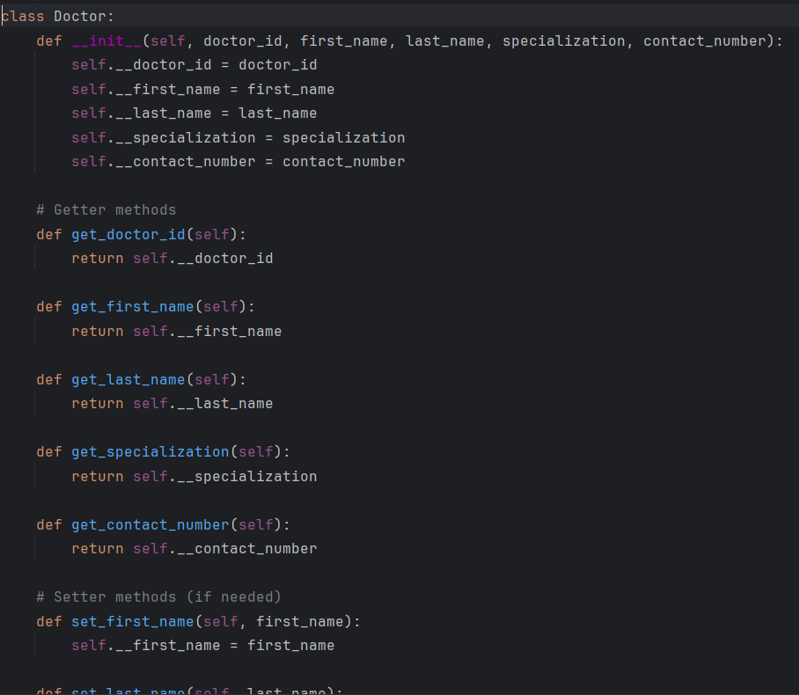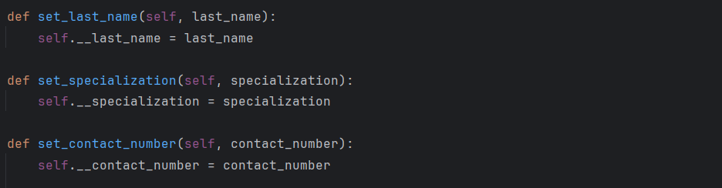

Creating `Appointment` class with the following confidential attributes:

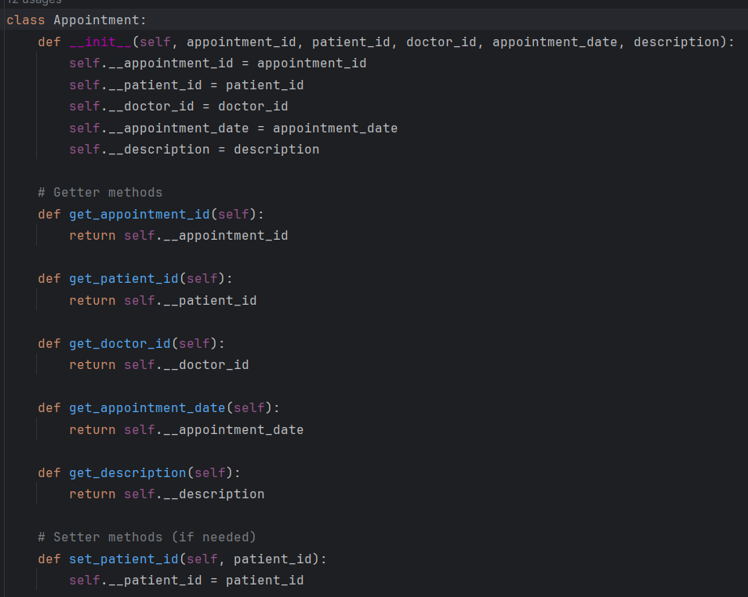

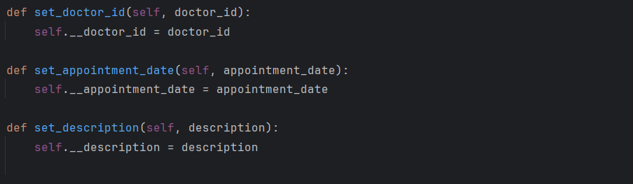

3.Define IHospitalService interface/abstract class with following methods to interact with database.

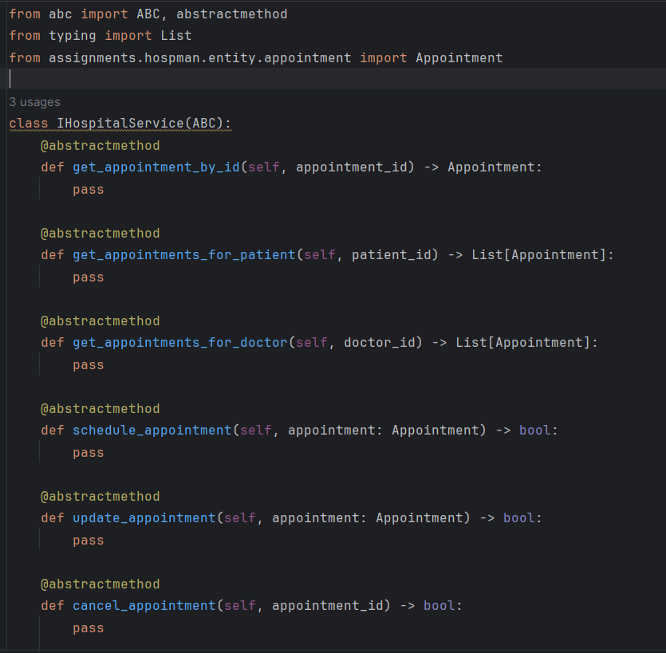

4.Define HospitalServiceImpl class and implement all the methods IHospitalServiceImpl.

getAppointmentById():

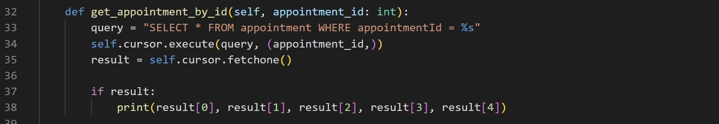  
getAppointmentsForPatient():

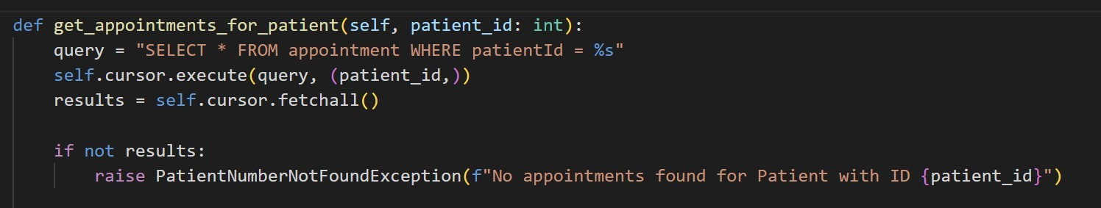  
getAppointmentsForDoctor():

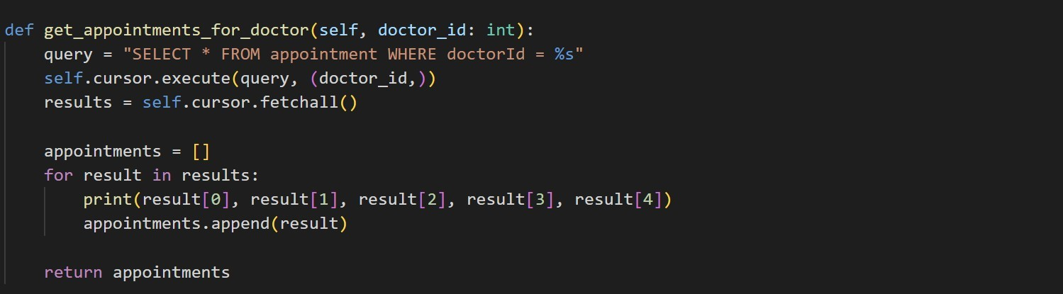

scheduleAppointment():

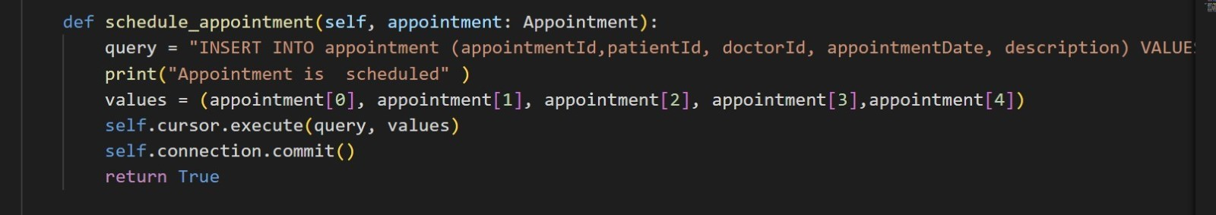

updateAppointment():

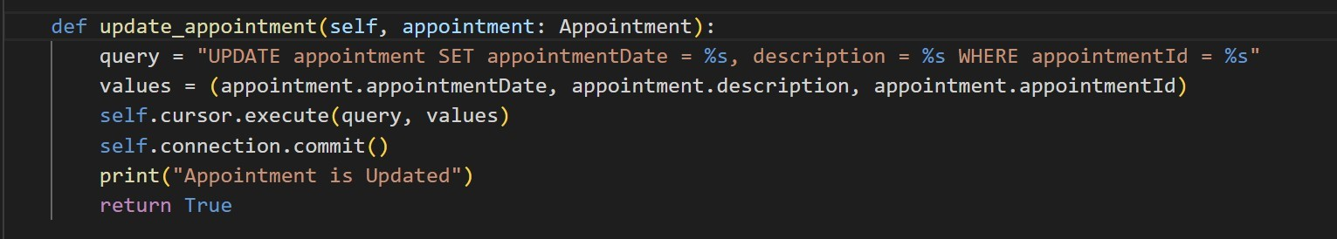  
CancelAppointment():

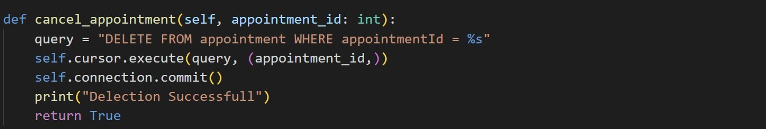

5.Create a utility class DBConnection in a package util with a static variable connection of Type Connection and a static method getConnection() which returns connection.

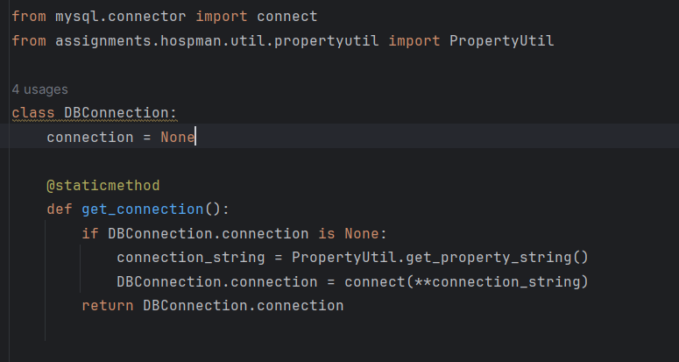

6.Connection properties supplied in the connection string should be read from a property file. Create a utility class PropertyUtil which contains a static method named getPropertyString() which reads a property fie containing connection details like hostname, dbname, username, password, port number and returns a connection string.

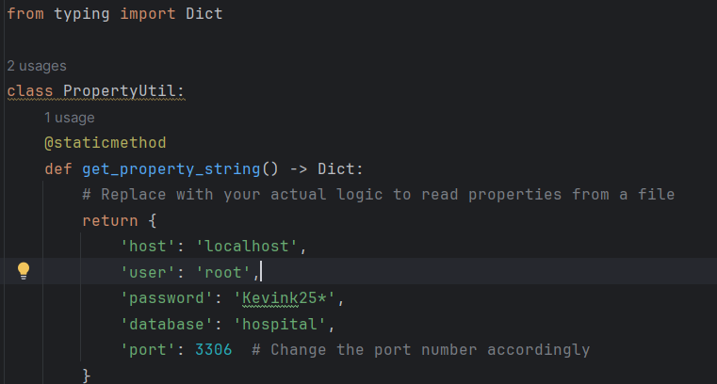

7.Create the exceptions in package myexceptions Define the following custom exceptions and throw them in methods whenever needed. Handle all the exceptions in main method



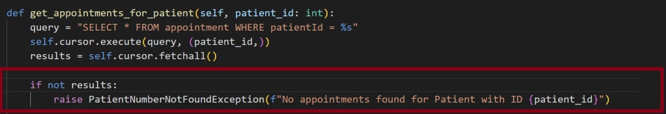

8.Create class named Mainapp with main method in package main and trigger all the methods in the implementation class.

